**LAB # 03**

**OBJECTIVE:**

To learn RMI basics: Generate the stubs and skeletons and run client and server.

Task 1: Create RMI program in which server performs basic arithmetic operations.

**Interface:**

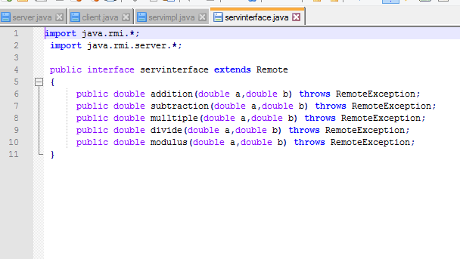

**Server Implementation:**

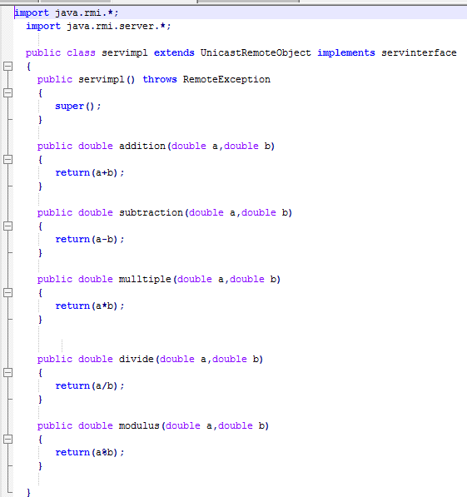

**Server:**

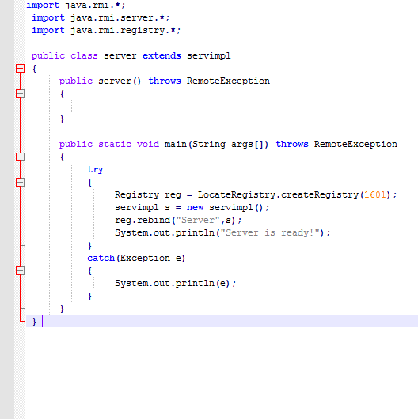

**Client**

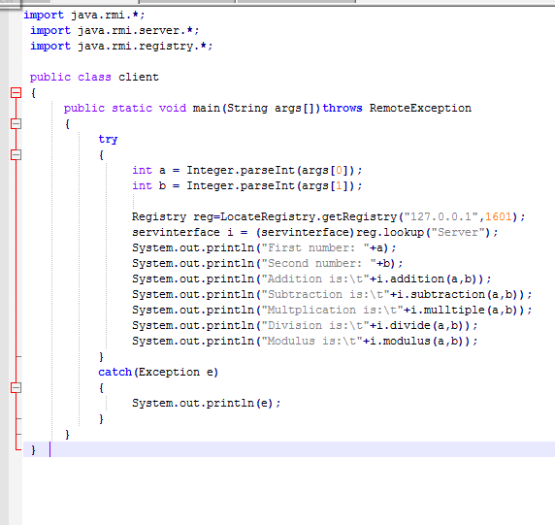

**OUTPUT:**

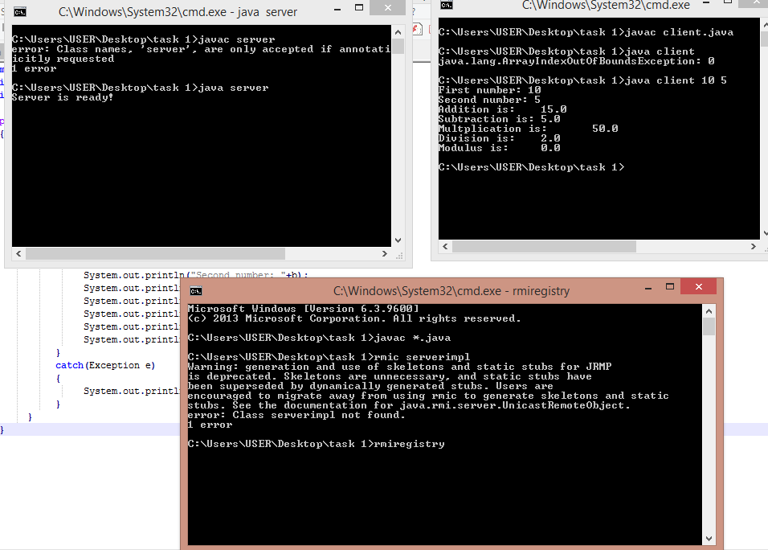

**Task2:** Create RMI program in which server sorts the numbers in ascending order.

**Interface:**

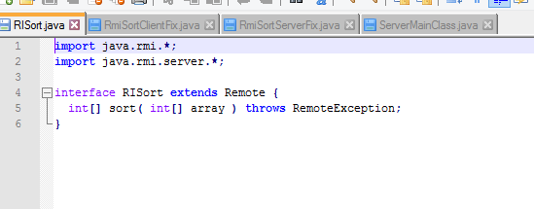

**Client:**

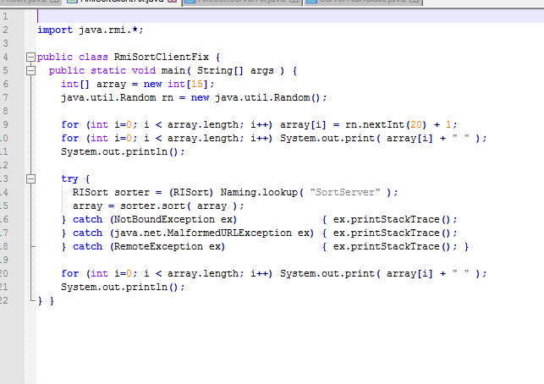

**Server:**

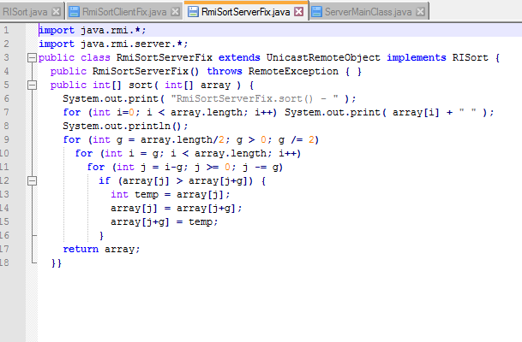

**ServerMain**

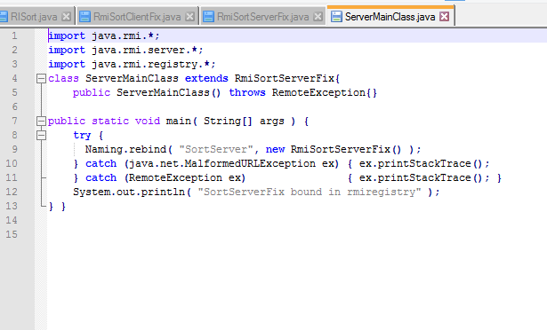

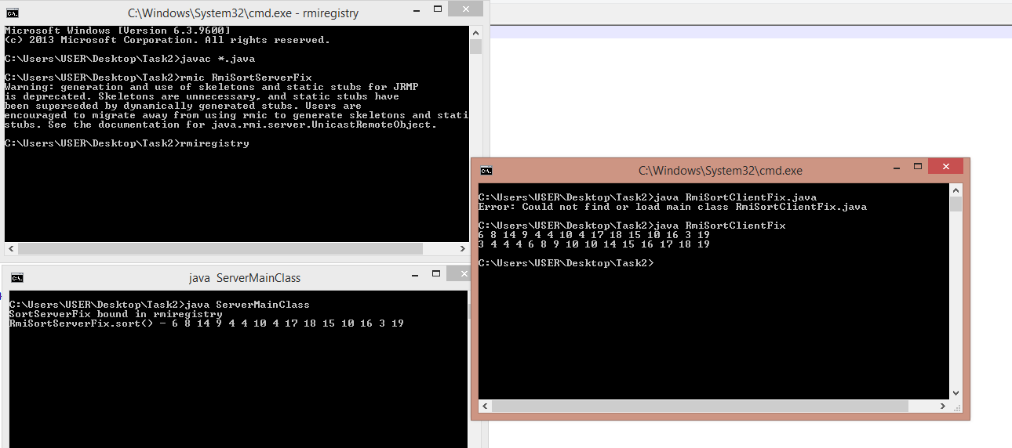

**Task:3**

**Write an RMI program to implement the Map/Reduce concept of Hadoop on the server program. In other words the client program asks user to provide multiple sentences and send to server, server sends back the word counts.**

**Interface:**

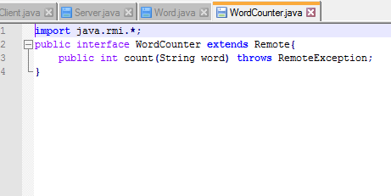

**WordCounter:**

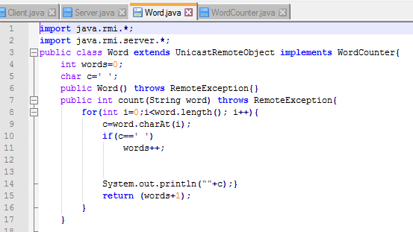

**Server:**

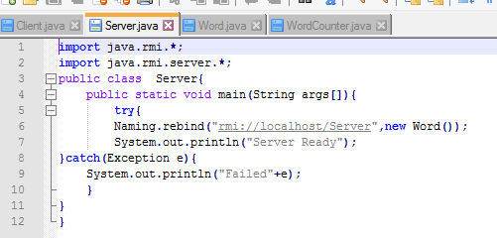

**Client:**

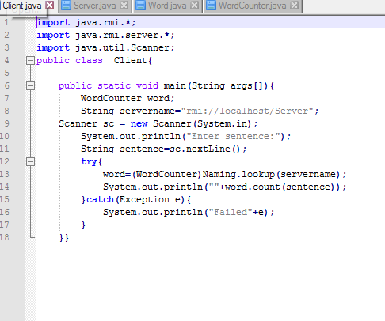

**OUTPUT:**

